*Business Analytics with R*

SQL Assignment - 1

Juhi Tatu

2237037

1Maeco

Date of Submission

30-03-2023

Submitted to

Mr. Abdul Majed Raja



MA APPLIED ECONOMICS

DEPARTMENT OF ECONOMICS

CHRIST (DEEMED TO BE UNIVERSITY)

August 2022

# TABLE SCHEMA

1. EMPLOYEE TABLE

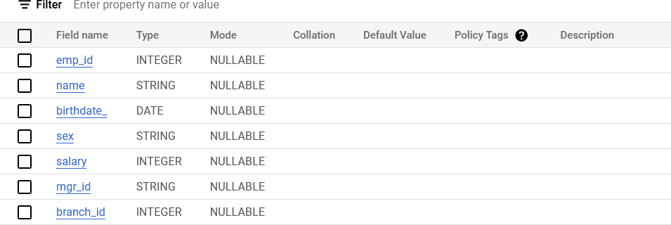

1. BRANCH TABLE

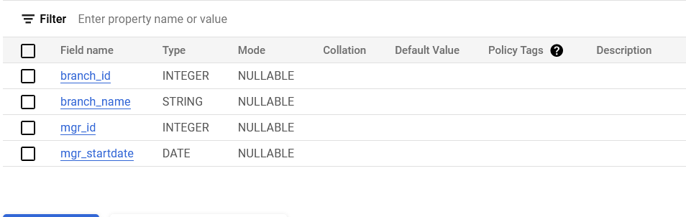

QUERIES

1. Write an SQL query, listing all the details of the female employees:

SELECT *

FROM baassign.SQL_Demo.EMP

WHERE sex = 'F';

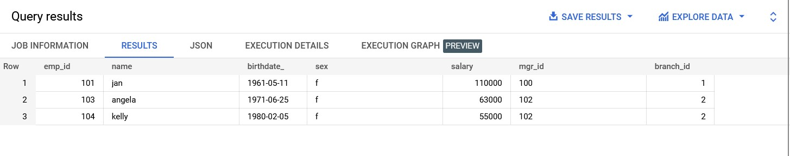

1. Write an SQL query, listing the number of male and female employees:

SELECT sex, COUNT(*) AS no_employees

FROM baassign.SQL_Demo.EMP

GROUP BY sex;

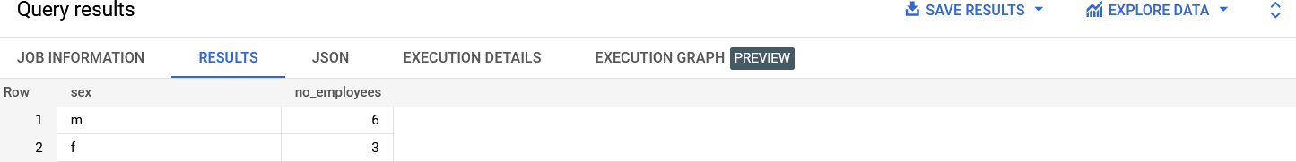

1. Write an SQL Query, listing the employees who have an income of more than 100,000:

SELECT *

FROM baassign.SQL_Demo.EMP

WHERE salary > 100000;

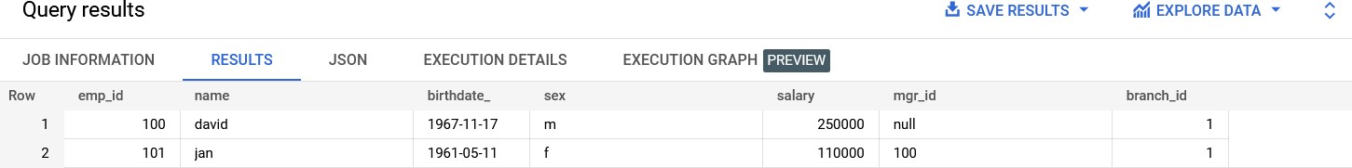

1. Write an SQL Query, listing the names of employees who are working in the branch named Stamford:

SELECT emp_id, name, salary

FROM baassign.SQL_Demo.EMP

WHERE branch_id = (

SELECT branch_id

FROM baassign.SQL_Demo.Branch

WHERE branch_name = 'Stamford'

);

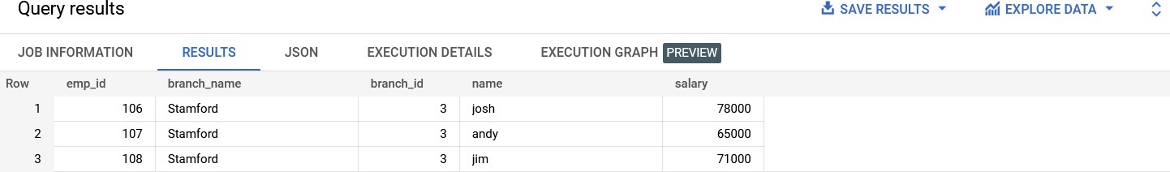

1. Write an SQL query, listing the number of employees in each branch with the number of employees in descending order:

SELECT b.branch_name, COUNT(*) AS no_employees

FROM baassign.SQL_Demo.EMP AS e

INNER JOIN baassign.SQL_Demo.Branch AS b ON e.branch_id = b.branch_id

GROUP BY b.branch_name

ORDER BY no_employees DESC;

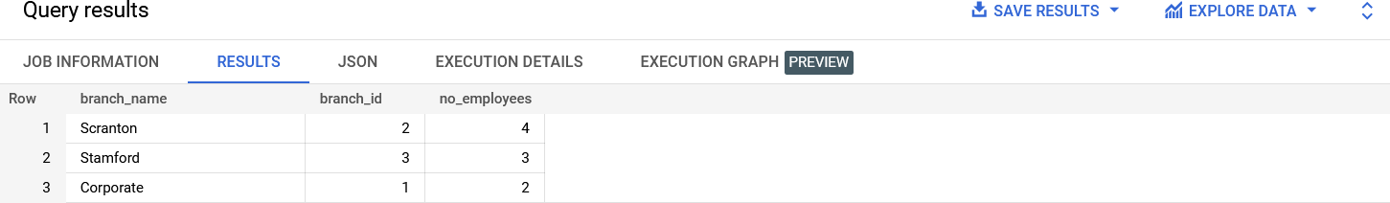

1. Write a SQL query to display the names of all departments along with the total number of employees in each department:

SELECT d.name AS department_name, COUNT(*) AS no_employees

FROM baassign.SQL_Demo.EMP AS e

JOIN baassign.SQL_Demo.DEPT AS d

ON e.dept_id = d.dept_id

GROUP BY d.name; ,

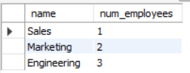

1. Write a SQL query to display the names and ages of all employees who work in the “Sales” or “Marketing” department.

SELECT name, TIMESTAMPDIFF(YEAR, birth_date, CURDATE()) AS age

FROM baassign.SQL_Demo.EMP AS e

JOIN baassign.SQL_Demo.DEPT AS d

ON e.dept_id = d.dept_id

WHERE d.name IN ('Sales', 'Marketing');

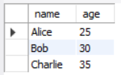

1. Write a SQL query to display the names and ages of all the employees who work in the “Engineering” department:

SELECT name, TIMESTAMPDIFF(YEAR, birth_date, CURDATE()) AS age

FROM baassign.SQL_Demo.EMP AS e

JOIN baassign.SQL_Demo.DEPT AS d

ON e.dept_id = d.dept_id

WHERE d.name = 'Engineering';

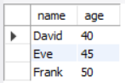

1. Write an SQL query, finding the annual income from the income table where the income is lesser than 50000 per annum arranged in descending order:

SELECT (income * 12) AS annual_income

FROM income

WHERE income < 50000

ORDER BY annual_income DESC;

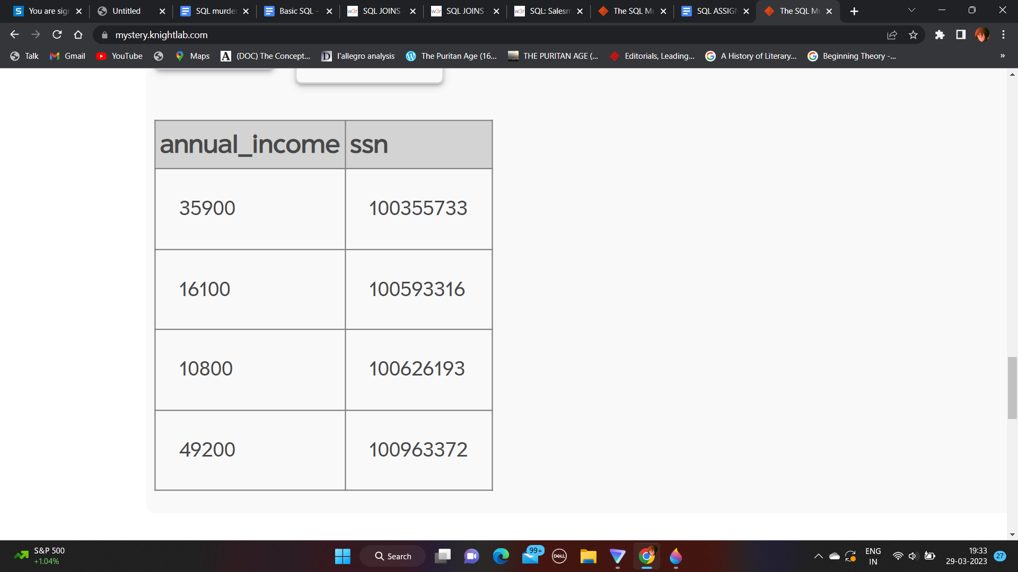

1. Write an SQL query, listing the names of employees who are working in Corporate and started working before 2000:

SELECT name

FROM EMP

INNER JOIN Branch ON EMP.branch_id = Branch.branch_id

WHERE branch_name = 'Corporate' AND start_date < '2000-01-01';

